**YEAR 11 GENERAL SCIENCE IN PRACTICE**

**Wheels in Motion**

**TASK 2: Reaction Time and Driving ASSESSMENT (10%)**

This **WRITTEN ASSESSMENT** will take **50 MINUTES** to complete in class.

**Conditions:**

This task contains THREE questions with a number of parts to assess the scientific method and the content from the science understanding topic – reaction time and driving.

Notes/reference material may not be used during this task.

This task will be completed individually.

**Task:**

This task contains a number of question types. You care required to:

* Provide single word, sentences or short paragraph responses
* Construct, use, interpret or analyse secondary data, graphs, tables or diagrams
* Perform mathematical calculations
* Provide responses making connections, drawing conclusions, constructing arguments, analysing and/or evaluating information

Your responses may incorporate labelled diagrams or tables with explanatory notes.

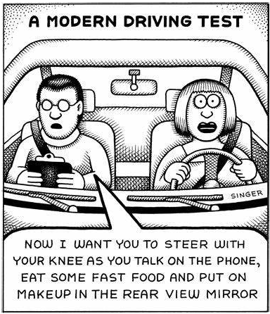

**Task weighting: 10%**

Name: ________________________________________________________________________

**Answer all questions in the spaces provided. (39 marks)**

Question 1 (14 marks)

Reacting when driving requires the proper functioning of the nervous system. The nervous system can be dived into a number of components. The chart below is a representation of these components.

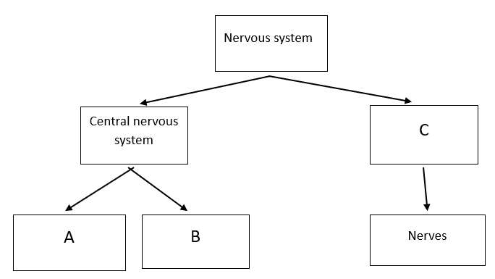

1. Identify the components missing from the chart above. Record your answers in the table below.

(3 marks)

|  |  |
| --- | --- |
| **Label** | **Component** |
| **A** |  |
| **B** |  |
| **C** |  |

The diagram below represents a cross-section of a human brain.

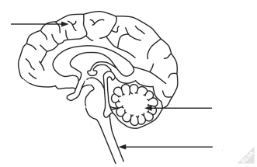

**A**

**C**

**B**

1. Refer to the diagram to complete the table below. (3 marks)

|  |  |  |
| --- | --- | --- |
| **Label** | **Name of part** | **Function of part** |
| **A** |  | Control of voluntary muscle contraction |
| **B** | Cerebellum |  |
| **C** |  | Carries impulses to and from the brain |

1. Describe the difference between a reaction and a reflex action. (2 marks)

____________________________________________________________________________

____________________________________________________________________________

____________________________________________________________________________

____________________________________________________________________________

____________________________________________________________________________

The diagram below shows a reflex arc.

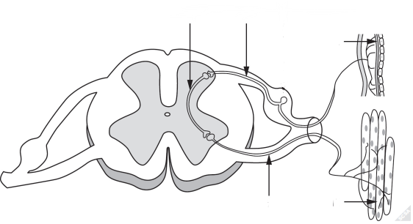

**A**

**muscle**

**C**

**B**

**muscle**

1. Using the labels in the diagram above identify the following components. (3 marks)

|  |  |
| --- | --- |
| **Component** | **Label** |
| Motor neuron |  |
| Sensory neuron |  |
| Interneuron |  |

Reflex actions follow the path of the reflex arc.

1. Explain how a reflex action protects the body. (3 marks)

____________________________________________________________________________

____________________________________________________________________________

____________________________________________________________________________

____________________________________________________________________________

____________________________________________________________________________

____________________________________________________________________________

Question 2 (12 marks)

1. Fatigue is one factor that can affect reaction time. Identify **two** other factors that can affect reaction time. (2 marks)

|  |  |
| --- | --- |
| **Factor 1** |  |
| **Factor 2** |  |

Mary and John wanted to investigate the effect of fatigue on a person’s reaction time.

They selected some students in their class to use as their test subjects and conducted the ruler drop test. At the start of the investigation the ruler drop test was measured three times for each participant. The measurements were converted to time, then calculated the mean reaction time.

**Ruler drop test**

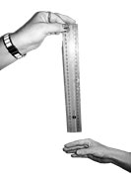 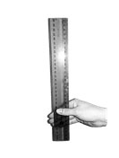



To simulate fatigue participants skipped, using a skipping rope, for 5 minutes before repeating the ruler drop test. This was repeated three times. The measurements were converted to time and the mean reaction time for the participant was calculated.

The results for the investigation are shown in the table on the next page.

|  |  |  |
| --- | --- | --- |
| Student | Mean reaction time when not fatigued (s) | Mean reaction time when fatigued (s) |
| Peter | 0.187 | 0.28 |
| Suzie | 0.243 | 0.407 |
| Darren | 0.14 | 0.25 |
| Stephanie | 0.203 | 0.287 |

1. Write a hypothesis for this experiment. (1 mark)

____________________________________________________________________________

____________________________________________________________________________

Below is another copy of Mary and John’s results.

|  |  |  |
| --- | --- | --- |
| Student | Mean reaction time when not fatigued (s) | Mean reaction time when fatigued (s) |
| Peter | 0.187 | 0.28 |
| Suzie | 0.243 | 0.407 |
| Darren | 0.14 | 0.25 |
| Stephanie | O.203 | 0.287 |

1. Draw a column graph showing results from the table above. (6 marks)



1. Write a conclusion for this investigation. (2 marks)

____________________________________________________________________________

____________________________________________________________________________

____________________________________________________________________________

____________________________________________________________________________

1. What improvement could the students make to the method, so the results are more valid?  
   Tick **one** box. (1 mark)

|  |  |
| --- | --- |
|  | Use alternate hands when catching the ruler |
|  | Carry out more repeats |
|  | Use a longer ruler for catching |
|  | Use more than two students to collect results |

Question 3 (13 marks)

Researchers investigated the relationship between the speed of a car and its stopping distance. The stopping distance of the car is the combination of the reaction distance and the braking distance, as shown in the diagram below.

**Reaction distance** refers to how far the car travels in the time it takes for the driver to react to a hazard and apply the brakes.

**Braking distance** refers to how far the car travels from the time the brakes are applied until it comes to a complete stop.

1. Complete the statement below to show the relationship between the reaction distance, braking distance and stopping distance. (1 mark)

Stopping distance = reaction distance ____________ braking distance

Data were collected from multiple trials at five different speeds to investigate the stopping distance of a car. They are shown in the table below. A light on the car was activated when the driver’s foot hit the brake pedal, to enable the reaction distance to be measured.

|  |  |  |  |
| --- | --- | --- | --- |
| Speed  (km/h) | Mean reaction distance  (m) | Mean braking distance  (m) | Mean stopping distance  (m) |
| 40 | 16 | 13 | 29 |
| 50 | 20 | 20 | 40 |
| 60 | 25 | 29 | 54 |
| 70 | 28 | 40 | 68 |
| 80 | 32 | 52 | 84 |

1. The data recorded in the table above is used in the graphical representation below. Fill in the missing values. (2 marks)

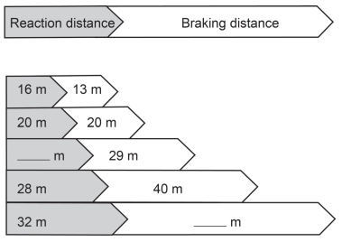

60 km/h

80 km/h

70 km/h

50 km/h

40 km/h

Speed

1. Identify the independent variable in the investigation. (1 mark)

___________________________________________________________________________

1. Given that at any speed the reaction time of the driver to respond to a hazard is about 1.44 s, explain why the reaction distance increases with speed. (2 marks)

___________________________________________________________________________

___________________________________________________________________________

___________________________________________________________________________

___________________________________________________________________________

Braking distances for a car travelling at 70.0 km/h, when the road surface is dry, is shown below. The minimum safe distance to maintain between vehicles under such conditions is 68 m.

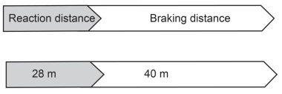

70 km/h

(dry)

Speed

A car is travelling at 70.0 km/h and maintains the suggested minimum distance of 68 m from the car in front. The car in front stops suddenly and the driver applies the brakes. The road surface is wet and the car is unable to stop in time, resulting in an accident.

1. Suggest possible values for the reaction and braking distances for a car travelling at 70.0 km/h on a wet road on image below. (2 marks)

70 km/h

(wet)

1. Explain why an accident occurred even though the driver kept the minimum distance of 68 m.

(5 marks)

___________________________________________________________________________

___________________________________________________________________________

___________________________________________________________________________

___________________________________________________________________________

___________________________________________________________________________

___________________________________________________________________________

___________________________________________________________________________

___________________________________________________________________________

___________________________________________________________________________

___________________________________________________________________________

**End of task**